**WEEK-3**

**SPRING DATA JPA WITH SPRING BOOT, HIBERNATE**

**Spring Data JPA - Quick Example**

**Path:**

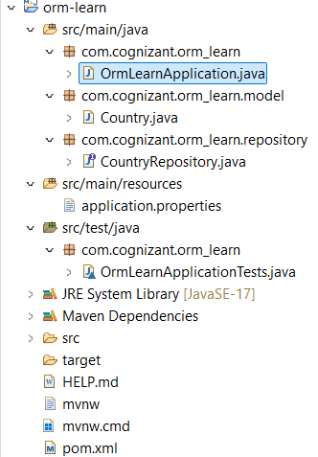

**Step 1:**

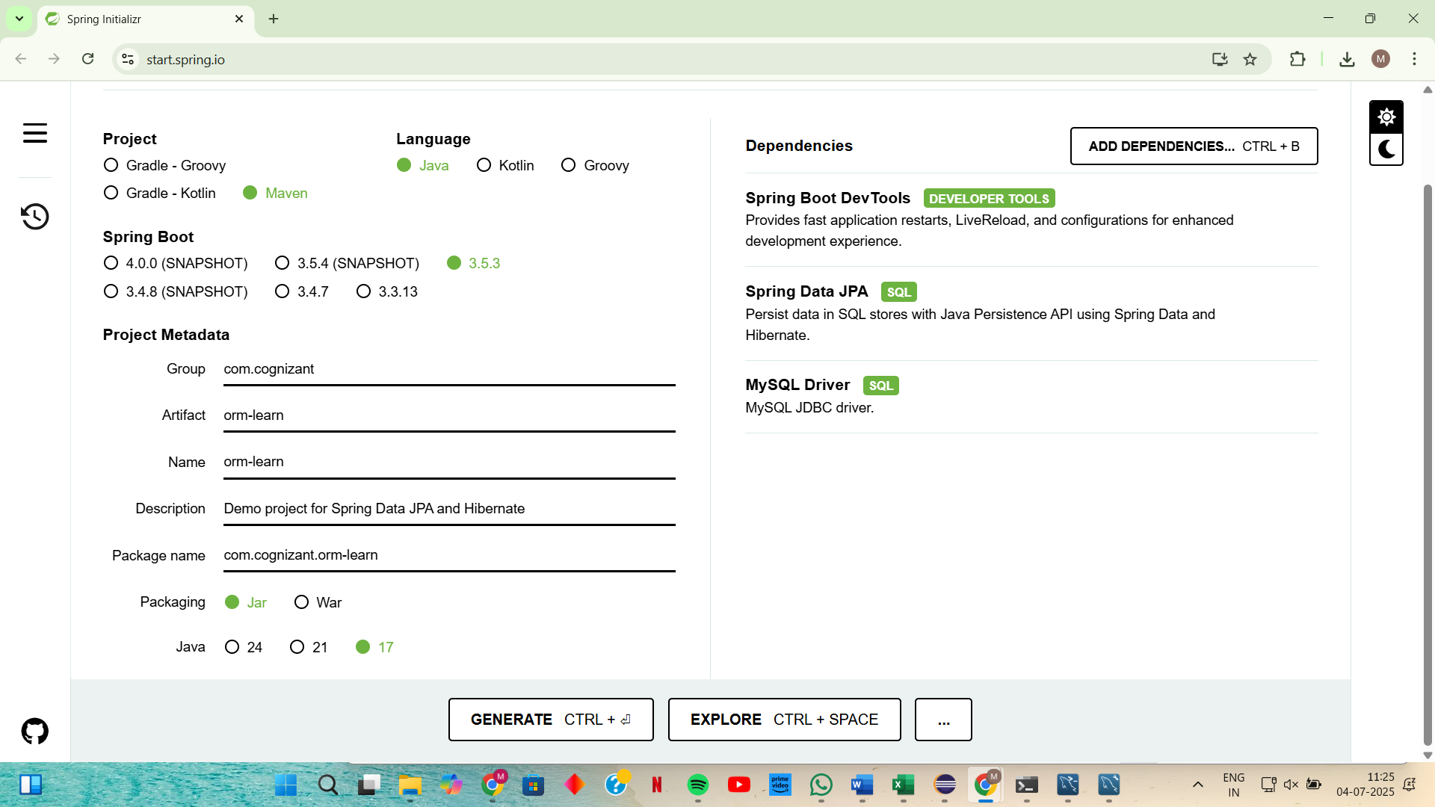

**Step 2: Update application.properties**

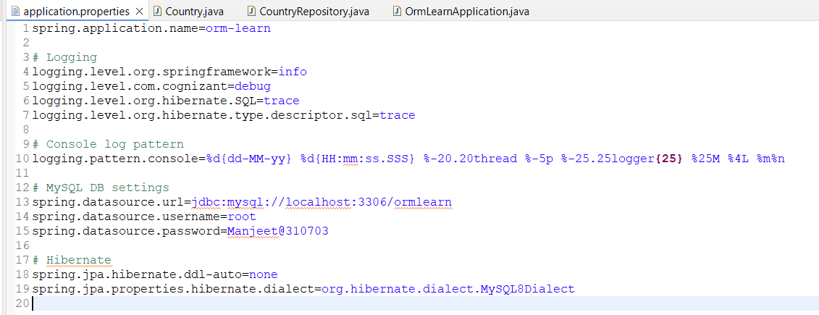

**Step 3: Created the model package and Country entity**

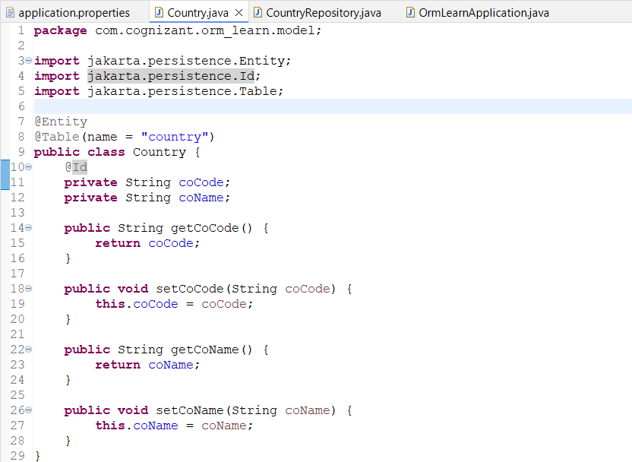

**Step 4: Create the repository package and interface**

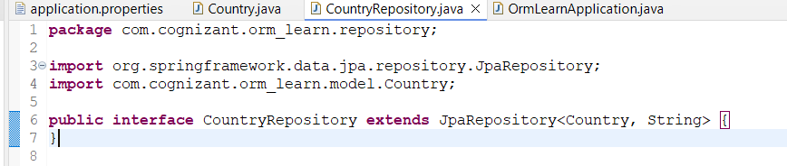

**Step 4: Updated OrmLearnApplication.java**

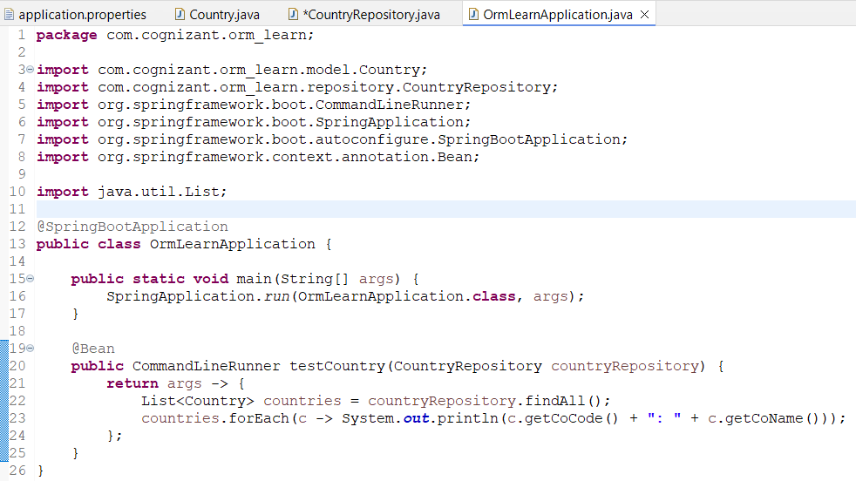

**OUTPUT:**

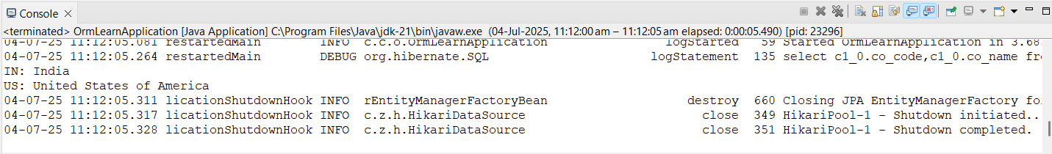

**EXERCISE 4:**

**Difference between JPA, Hibernate and Spring Data JPA**

|  |  |  |  |
| --- | --- | --- | --- |
| **Feature** | **JPA (Java Persistence API)** | **Hibernate** | **Spring Data JPA** |
| **Type** | **Specification (Interface only)** | **Implementation (ORM Framework)** | **Abstraction layer built on top of JPA and Hibernate** |
| **Purpose** | **Defines standard API for ORM** | |  | | --- | |  |  |  | | --- | | **Implements JPA and adds advanced ORM features** | | **Simplifies JPA/Hibernate usage and reduces boilerplate** |
| **Boilerplate Code** | **More manual coding (DAOs, queries)** | **Less than JPA, still manual repository setup** | |  | | --- | |  |  |  | | --- | | **Minimal – auto-generates repositories** | |
| **Integration with Spring** | **Manual setup needed** | **Partial support** | |  | | --- | |  |  |  | | --- | | **Fully integrated and optimized for Spring** | |
| **Ease of Use** | |  | | --- | |  |  |  | | --- | | **Moderate – requires configuration** | | **Easier – supports annotations** | **Very easy – Spring integration + derived queries** |

**Step 1: Create “Employee.java” class under “model” folder.**

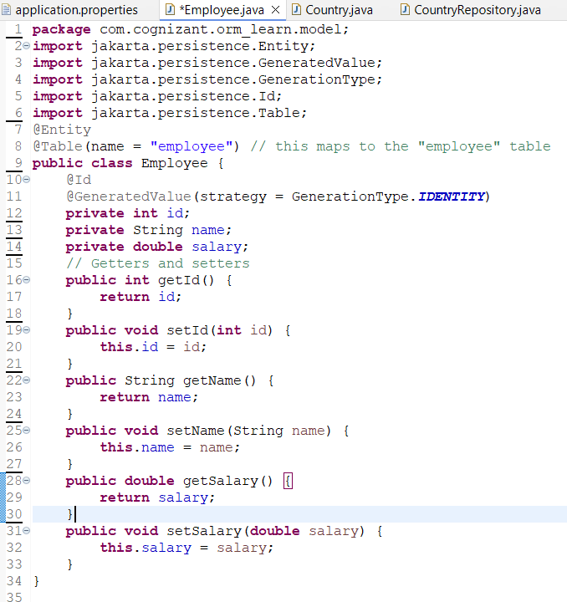

**Step 2: Create the Repository Interface inside a new package: com.cognizant.orm_learn.repository** 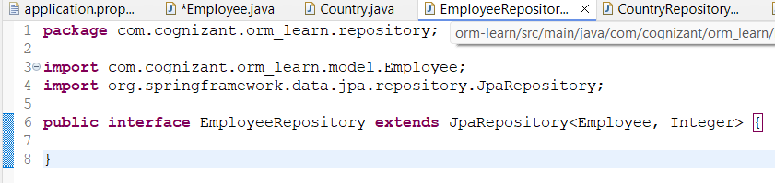

**Step 3: Create the Service Class inside com.cognizant.orm_learn.service:**

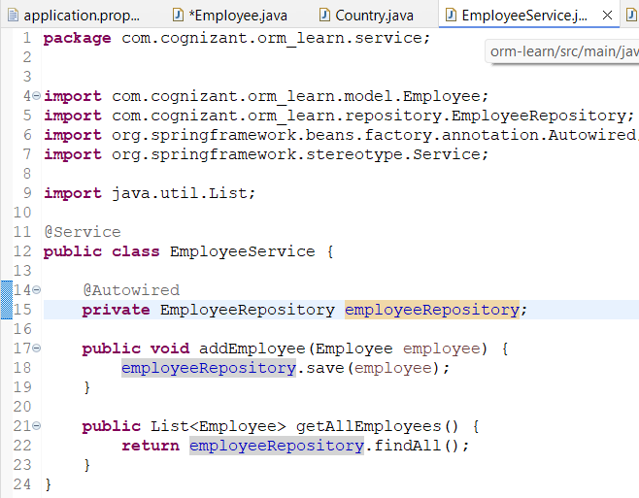

**Step 4: Update OrmLearnApplication.java to test:**

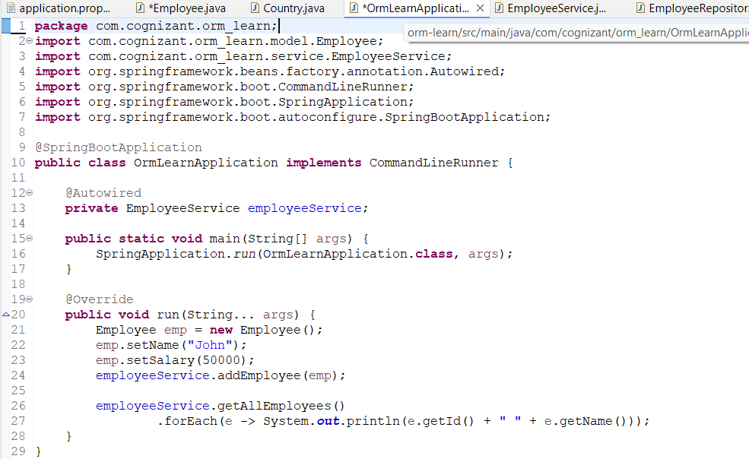

**Step 5 : Also update the application.properties file**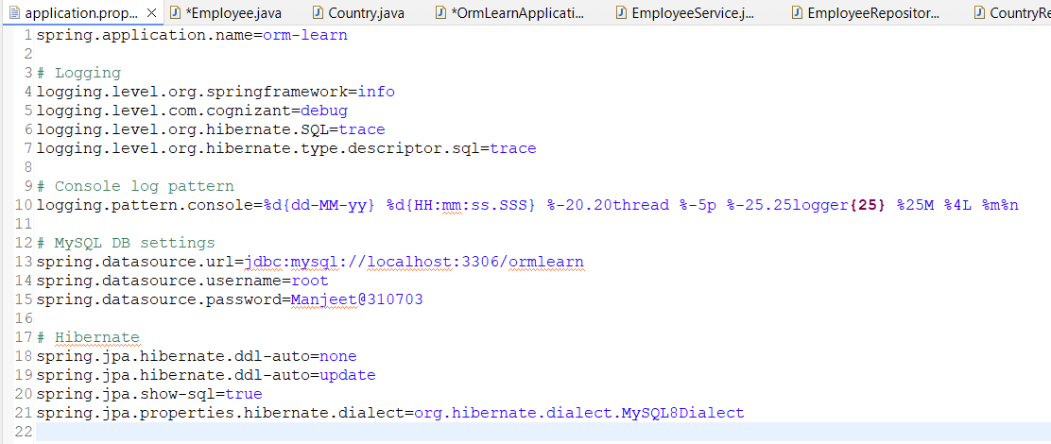

**OUTPUT:**

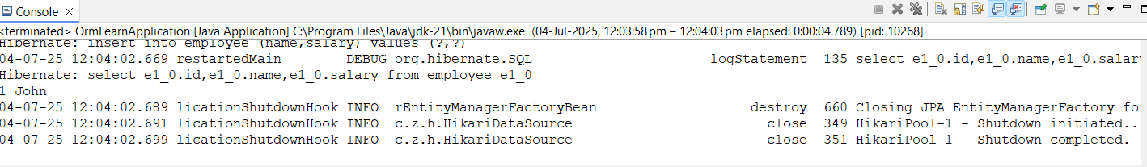

**Full Screenshot Console:**